ASSESSMENT OF MARGINAL WORKERS IN TAMIL NADU.

A SOCIOECONOMICAN ANALYSIS (ADS).

## Project 7: Assessment of Marginal Workers in TamilNadu.

**Phase 1: Problem Definition and Design Thinking**

In this part you will need to understand the problem statement and create a document on what have you understood and how will you proceed ahead with solving the problem. Please think on a design and present in form of a document.

**Problem Definition:** The project involves analyzing the demographic characteristics of marginal workers in Tamil Nadu based on their age, industrial category, and sex. The objective is to perform a socioeconomic analysis and create visualizations to represent the distribution of marginal workers across different categories. This project includes defining objectives, designing the analysis approach, selecting appropriate visualization types, and performing the analysis using Python and data visualization libraries.

**Design Thinking:**

1. Project Objectives: Define objectives such as analyzing marginal worker demographics, understanding age and gender distribution, and exploring industrial categories.
2. Analysis Approach: Plan the steps to extract, clean, and analyze the dataset to derive insights.
3. Visualization Selection: Determine suitable visualization types (e.g., bar charts, pie charts, heatmaps) to represent demographic distributions effectively.

**INTRODUCTION:**

* Marginal worker is **a person who might have done some work any time during the previous year, but not for the major part of the year**.
* **Those workers who had not worked for the major part of the reference period (i.e. less than 6 months)** are termed as Marginal Workers. Work is defined as participation in any economically productive activity with or without compensation, wages or profit. Such participation may be physical and/or mental in nature.According to economic status, population in India is divided into: (a) Main workers: a person who works for at least 183 days in a year. (b) Marginal workers: **who works for less than 183 days or 6 months in a year**.

**THE FOUR MAJOR CATEGORIES:**

• Cultivators.

• Agricultural Labourers.

• Household Industrial Workers.

• Other Workers.

**THE FOUR MAJOR TYPES OF LABOR ARE:**

* professional,
* semi-skilled,
* skilled, and
* unskilled labor.

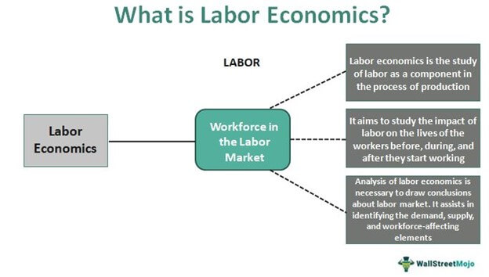

Assertion: The working population classified according to occupations is known as **occupational structure**. Reason: Occupational structure indicates development of a country.

NEW CATEGORIES FOR CENSUS 2023:

1. Gender: New category “Other” introduced in addition to Male and Female.   
  
2. Date of Birth question introduced along with Age.   
  
3. Current Marital Status: Separate codes Assigned for Separated and Divorced.   
  
4. New filter Question on SC/ST Introduced – “Is this person SC/ST?”

5. Disability: The question on disability canvassed at the Census 2001 has been modified. Household Schedule attempts to collect information on eight types of disabilities as against five included in the Household Schedule of Census of India 2001. The information is being collected on disabilities namely, disability ‘In Seeing’, ‘In Hearing’, ‘In Speech’, ‘In Movement’, ‘Mental retardation’, ‘Mental Illness’, ‘Any Other’ and ‘Multiple Disability’.   
  
6. Literacy Status for “Other” sex added in addition to existing Male and Female.   
  
7. New Codes under Status of Attendance in Educational Institutions introduced for Not Attending viz., (i) Attended before and (ii) Never attended.   
  
8. Work: In the previous censuses, workers were categorized as ‘Main workers’ and ‘Marginal workers’. Those who worked for more than 6 months during last year were categorized as ‘Main workers’ whereas those who worked less than 6 months were categorized as ‘Marginal Workers’. At the Census 2011, for better capturing and analysis of Census data, ‘Marginal workers have been classified into two categories viz., (i) worked for 3 months or more but less than 6 months (ii) worked for less than 3 months. The definition of ‘Main worker’ remains the same.   
  
9. A separate code-5 has been included under Non-economic activity for rentiers.   
  
10. Migration – Provision to specify the present name of the Village/Town of the Birth Place as well as the Place of Last Residence introduced.   
  
11. Name of the Institutional Household is also being recorded.   
  
This was stated by the Minister of State in the Ministry of Home Affairs, Shri Gurudas Kamat in written reply to a question in Rajya Sabha today.

A SOCIOECONOMICAN ANALYSIS (ADS):

**INTRODUCTION:**

One of the main objectives of socioeconomic assessment is **to identify various socioeconomic positive and negative impacts**. The socioeconomic impacts assessment should highlights possible relationships between assessed socioeconomic variables and the environmental quality in the study site.

**SOCIO-ECONOMIC ANALYSES:**

**Socio-economic analyses can help us assess the benefits and costs associated with climate change adaptation measures.**

* socio-economic analyses to calculate the value of advantages and disadvantages for society of different climate change adaptation measures. In this way we can find the measures that will be of greatest use for society or which are the most cost-effective.

Socio-economic screening of climate change adaptation:

The Ministry of Climate and Energy has published a cross-sector, national socio-economic screening of climate change adaptation, June 2010.  An English summary of the report can be downloaded from the publication list.

* The screening looks at climate adaptation across the 14 sectors dealt with in the government's climate change adaptation strategy from 2008.
* The screening indicates that coastal protection, buildings, roads/railways and sewerage are especially relevant candidates for more in-depth analyses. Potential damage costs are high in these sectors, and the example calculations indicate that these sectors have the greatest potential for limiting damage costs in a cost-effective manner through adaptation measures.
* The sectors mentioned are characterised by long-term investments, and this calls for early incorporation of climate change adaption. Within the sector of coastal protection however, it is possible to implement adaptation

**PARTIAL ANALYSES:**

* Socio-economic assessments of climate change adaptation measures are often carried out as partial analyses (as is also the case in other areas). This means that only the effects that can be directly or indirectly linked to the measure are quantified and valued.
* This partial approach has the advantage of being well defined, the results are simple and easy to interpret, and it opens up for numerous different methods of calculation of consequences. The disadvantage is that we cannot be sure that what is optimal in the analysis of a measure is also optimal in general. This makes it more difficult to compare results across measures.

**SOCIO-ECONOMIC ANALYSIS IN FEASIBILITY STUDY**:

The socio-economic aspect of a project feasibility study involves **analyzing the broader social and economic implications of the project**. It aims to evaluate how the project will contribute to the socio-economic development of the area, address social needs, and enhance the quality of life for the community.

**SOCIO-ECONOMIC CHALLENGES:**

* Some of the most significant examples of socio-economic issues would include things like: **Income levels within a community**. The kind of educational opportunities that exist. The employment situation of a community. Safety within a community.
* The climate change adaptation area raises certain methodological issues.  These occur because calculations are made for very long time horizons, and because there is substantial uncertainty linked to the future effects. Socio-economic analyses in the climate change adaptation area are relatively new, both in Denmark and elsewhere. Methods are under continuous debate and development.

